**DAILY ONLINE ACTIVITIES SUMMARY**

|  |  |  |  |  |  |  |  |  |
| --- | --- | --- | --- | --- | --- | --- | --- | --- |
| **Date:** | **12/06/2020** | | | | | **Name:** | **Lavanya D M** | |
| **Sem & Sec** | **4th & ‘A’** | | | | | **USN:** | **4al18cs041** | |
| **Online Test Summary** | | | | | | | | |
| **Subject** | | **kannada** | | | | | | |
| **Max. Marks** | | **25** | | **Score** | | | **11** | |
| **Certification Course Summary** | | | | | | | | |
| **Course** | **VMware lab** | | | | | | | |
| **Certificate Provider** | | | **Bitdegree** | | **Duration** | | | **1 week** |
| **Coding Challenges** | | | | | | | | |
| **Problem Statement:1)** Given two positive integer start and end. The task is to write a Python program to print all Prime numbers in an Interval.  **2)** Java program to calculate the average of N numbers | | | | | | | | |
| **Status: complied** | | | | | | | | |
| **Uploaded the report in Github** | | | | | **Yes** | | | |
| **If yes Repository name** | | | | | <https://github.com/lavanyamurthi/lockdown-coding> | | | |
| **Uploaded the report in slack** | | | | | **Yes** | | | |

Online Test Details: (Attach the snapshot and briefly write the report for the same)

Certification Course Details: (Attach the snapshot and briefly write the report for the same)

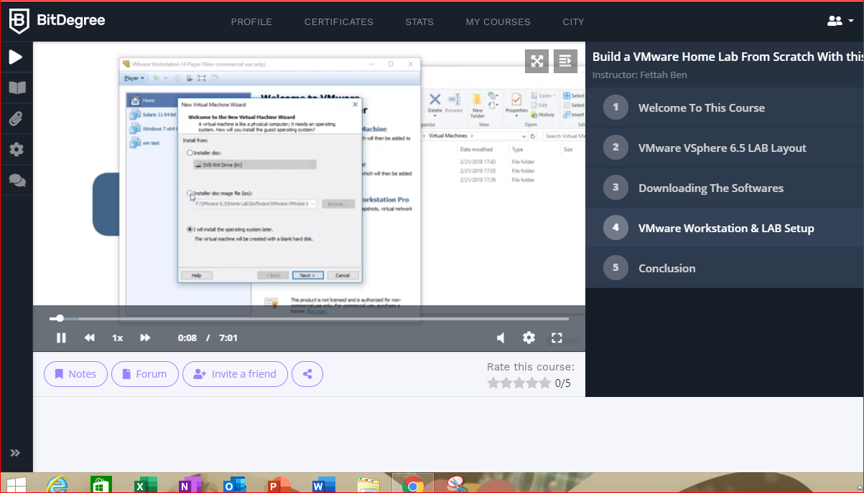

Coding Challenges Details: (Attach the snapshot and briefly write the report for the same)

Problem 1: Given two positive integers start and end. The task is to write a Python program to print all Prime numbers in an Interval

Explanation : A prime number is a natural number greater than 1 that has no positive divisors other than 1 and itself. The first few prime numbers are {2, 3, 5, 7, 11, ….}. The idea to solve this problem is to iterate the val from start to end using a for loop and for every number, if it is greater than 1, check if it divides n. If we find any other number which divides, print that value

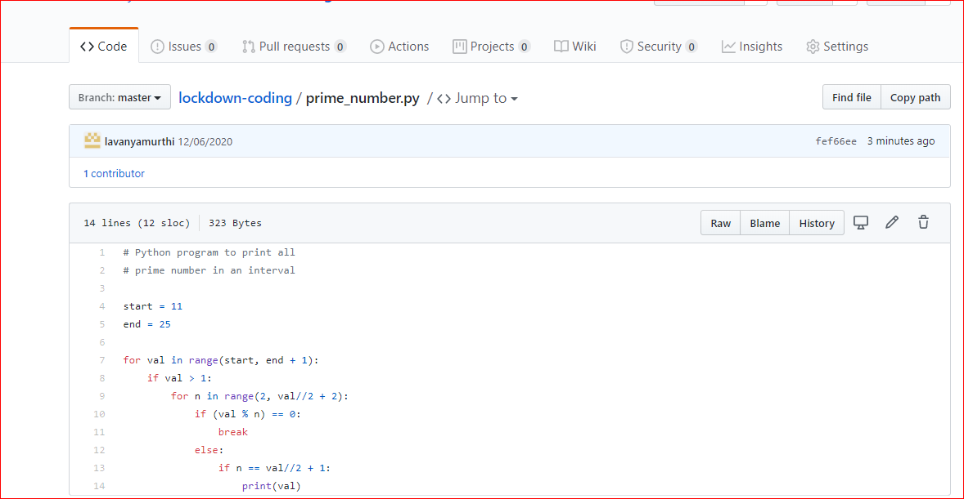

Problem 2: Java program to calculate average of N numbers

